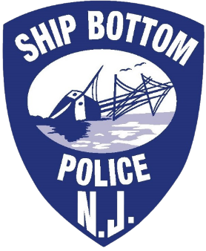

FULL TIME Police Officers
***In addition to PoliceApp questionnaire, please download and fill out the Ship Bottom Department application which you can find underneath the "APPLY" button above. Completed applications must be hand delivered / mailed to the Ship Bottom Police Department, 1621 Long Beach Blvd. Ship Bottom, NJ 08008.
The Ship Bottom Police Department is now accepting applications for: Full Time Police officers.

Minimum qualifications:
- Must have valid SLEO 2 New Jersey certification or Full Time Police Officer certification
- Must be at least 18 years of age and no older than 35 years of age at their time of appointment (N.J.S.A. 43:16A-3(1))
- Must posses a High School diploma or equivalent
- Must posses a valid New Jersey drivers license
- Must be a resident of New Jersey at the time of employment
- Must be able to read, write and speak the English language well and intelligently
- Must be of good moral character and shall not have been convicted of any crime

Hiring Process:
- Review of submitted application
- Formal interview
- Complete background investigation
- Medical / Psychological / Drug exams upon receipt of conditional offer of employment
- Sign conditional offer of employment

Salary:
- $55,853.21 (salary negotiable)

Deadline:
- Application process will close on 09/14/2026
It is the policy of the Ship Bottom Police Department to provide and encourage equal employment and business opportunity for all persons and to prohibit discrimination in employment and business practices. This department shall not discriminate on the basis of any sensory, mental, or physical disability in employment unless such a disability prevents the performance of the essential duties required of the position and which are bona fide occupational qualifications which cannot be accommodated without undue hardship.
The Ship Bottom Police Department is an Equal Opportunity Employer
***Please direct questions regarding this position to Ptl. Mathew Chester @ mchester@shipbottom.org or 609-494-3055x176

